AURA WATCHES



**PREPARED BY**

**Vaneeza**

**Saboor khan**

**M.Rahib**

**M.Fasseh**

|  |  |
| --- | --- |
| Batch: AI-202409B | |
| Student Id | Name |
| 1603999 | Mr. Muhammad Faseeh Mamdani |
| 1603933 | Mr. Muhammad Rahib |
| 1608129 | Mr. Abdul Saboor |
| 1603928 | Ms. Vaneeza Nazar |





Table of Contents

**CERTIFICATE OF COMPLETION** 4

**INTRODUCTION** 5

**DEDICATION:** 6

**PROBLEM STATEMENT** 6

**REQUIREMENT SPRECIFICATION** 6

**Hardware/ Software Requirements:** 8



# **CERTIFICATE OF COMPLETION**

This is to inform you that M. Faseeh Mamdani, Muhammad Rahib, Abdul Saboor and Vaneeza Nazar have successfully completed their ACCP AI Semester I E-Project.

**Submitted to:**

Aptech Metro Star Gate

**Date:**

27 FEB 2025

# **INTRODUCTION**

The thirst for learning, upgrading technical skills, and applying concepts in real-life environments at a fast pace is what the industry demands from IT professionals today. However busy work schedules, far flung locations and the unavailability of convenient time slots pose major barriers when it comes to applying the concepts to realism. Hence the need to look out for alternative means of implementation in the form of a laddered approach. The above truly poses a constraint, especially for our students too! With their busy schedules, it is indeed difficult for our students to keep up with the genuine and constant need for an integrated application which can be seen live especially so in the field of IT education where technology can change on the spur of the moment. Well, technology does come to our rescue at such times!! Keeping the above in mind and in tune with our constant endeavor to use Technology in our training model, we at Aptech have thought of revolutionizing the way our students learn and implement the concepts using tools themselves by providing a live and synchronous e-Project learning environment!

# **DEDICATION:**

I dedicate this project to my respectable, sincere “Teacher” Miss S Fatima Nazi.

# **PROBLEM STATEMENT**

Aura watches is into business of manufacturing and selling watches. They have been advertising about their clocks and watches through newspapers, pamphlets, television. Now with changing times, they have decided to go online as customers today use Internet extensively. They have planned for a website with complete details about their watches and clocks.

# **REQUIREMENT SPRECIFICATION**

The Web site is to be created based on the following requirements.

1. The Home Page should have suitable logo, and decent colour combination.
2. The site should display a menu which will contain the options as Products, Technology, Store Locator, Support etc.
3. Various pages having information about different types of watches and clocks, Technology used in the watches etc.
4. The information should be categorized according to different Product Line-up e.g. “SPORTZ”, “PREMIER” etc.
5. When a user selects any product line-up, complete list of watches for that product line-up will be displayed.
6. Details of the watches should be displayed on the Web Page along with the title and it should be stored in Individual Word documents which can be downloaded or viewed by the User who wishes to see the same.
7. Price List for all watches should be available for download.
8. There should be a “Contact Us” page which will have the Address of the Stores selling watches and the mail address which when clicked will invoke the local mail client from where they can send an email.

# **Hardware/ Software Requirements:**

**Hardware**

* A minimum computer system that will help you access all the tools in the courses is a Pentium 166 or better
* 64 Megabytes of RAM or better

**Software *[Either or Combination as per Course/Sem]***

* Notepad/HTML editor/CoffeeCup
* Angular / Angular JS / React / BootStrap
* Dreamweaver / Figma
* MS IE / Chrome / FireFox / Netscape /MS Edge

# **SCREENSHOTS:**

## HOME PAGE:

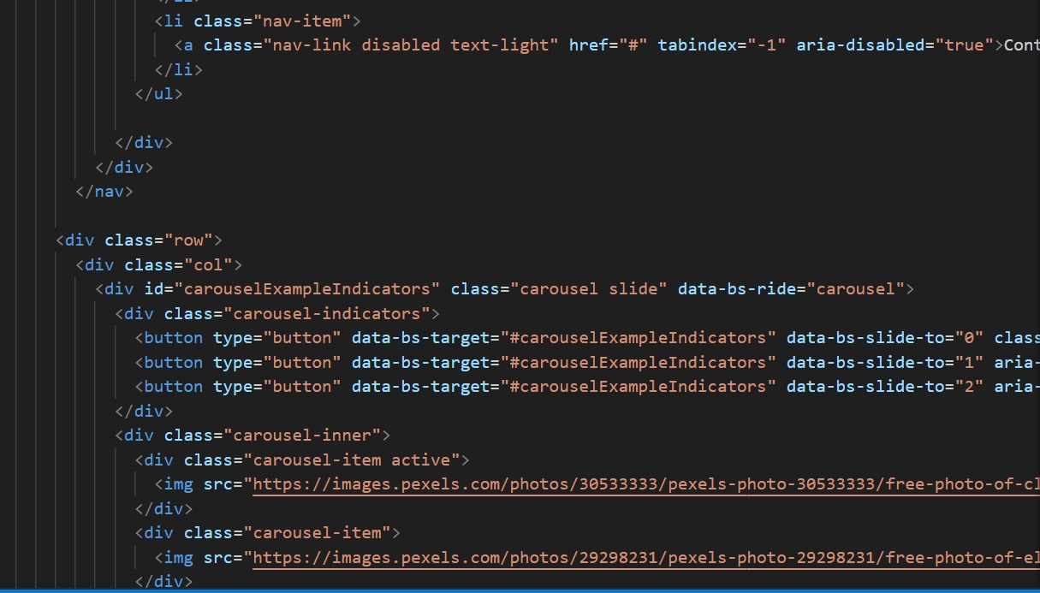

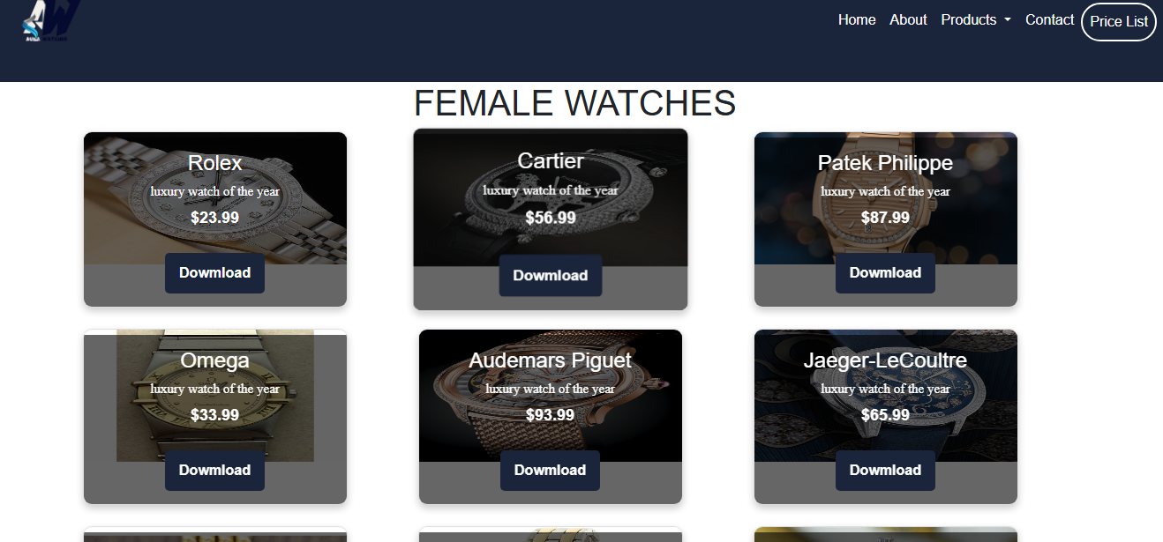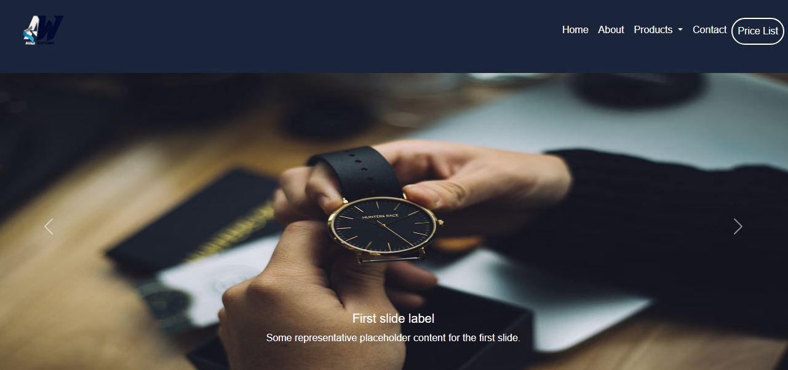

# **ERD DIAGRAM:**

**PRODUCT**

**FOOTER**

**KIDS**

**WOMEN**

**MEN**

**CONTACT US**

**CLOCKS**

**SPORTS**

**PREMIUM**

**ABOUT**

**HOME PAGE**